A

PROJECT DAIRY ON

“EMPLOYEE LEAVE MANAGEMENT SYSTEM”

Submitted By,

PANDARKAR ABHISHEK DNYANDEV

ROLL NO-63

MCA-1

IN PARTIAL FULLFILLMENT OF

MASTER OF COMPUTER APPLICATION

For

INSTITUTE OF MANAGEMENT STUDIES AND CARRER DEVELOPMENT AND RESEARCH.

NAAC RE-ACCREDITED: A+ GRADE

Affiliated To

SAVITRIBAI PHULE PUNE UNIVERSITY

ACADEMIC YEAR (2021-22)

**INTRODUCTION**

This project is aimed at developing an Employee Leave Management system, that is of importance to either an organization. The Leave Management System (ELMS) is an internet based application that can be accessed throughout the organization or a specified group/Dept.

This system can be used to automate the workflow of leave applications and their approvals. The periodic crediting of leave is also automated. There are features like apply for leave, the admin can approval of leave, add leave types, also can add employees and departments etc. in this system. Leave Management application will reduce paper work and maintains record in more efficient way.

In the existing paper work related to leave management, leaves are maintained using the attendance register for staff. The staff needs to submit their leaves manually to their respective authorities. This increases the paperwork & maintaining the records becomes tedious.

I chose Employee leave management software as the system seemed simple and easy to use. During its development we realized that we needed software that may help to manage leave activities and various other adjustment like add department, view leaves.

**SCOPE**

* Employee Module
* Admin Module

**Admin Module details:**

* Admin can add/update leave type and departments
* Admin can add an employee and also update the employee info. Also can active or block an employee.
* Admin can also manage the leave application(approve and not approve).
* Every time when an employee applies for leave admin will get a notification.
* Admin can change own password after login.
* Admin can also view admin dashboard

**Employee Module details:**

* Employee can login with the valid email and password.
* Update his/her profile
* Applied for leave
* View the leave history
* Change his/ her password
* Password Recovery with the valid email id and empid
* View Leave History

**USE CASE DAIGRAM**

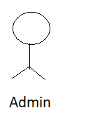 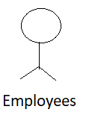

**SCREEN SHOTS**

**Admin Login:**

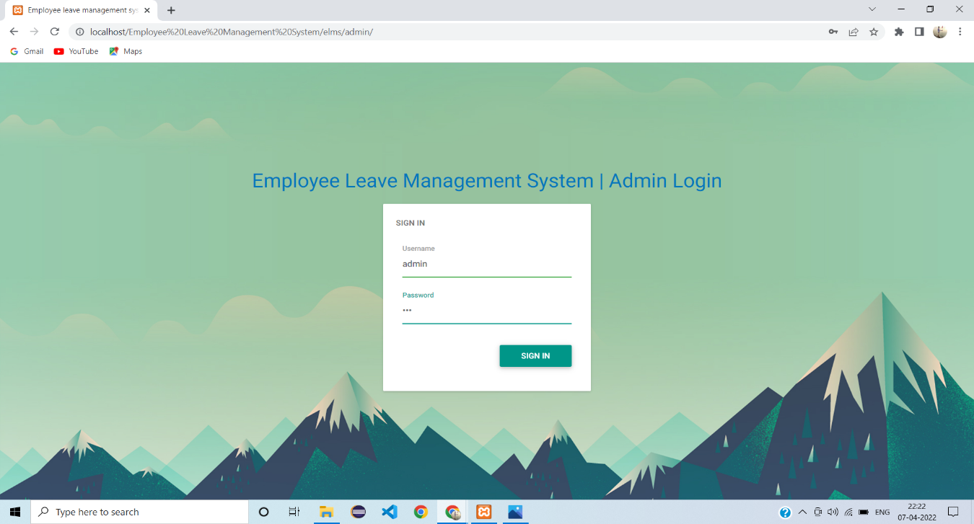

**Dashbord:**

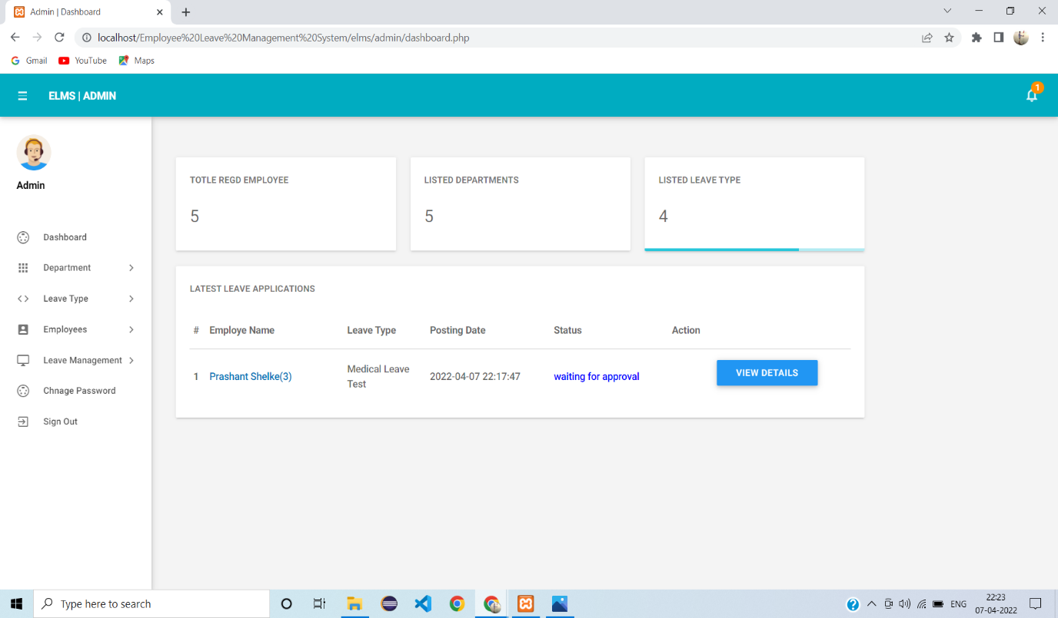

**Add Employee:**

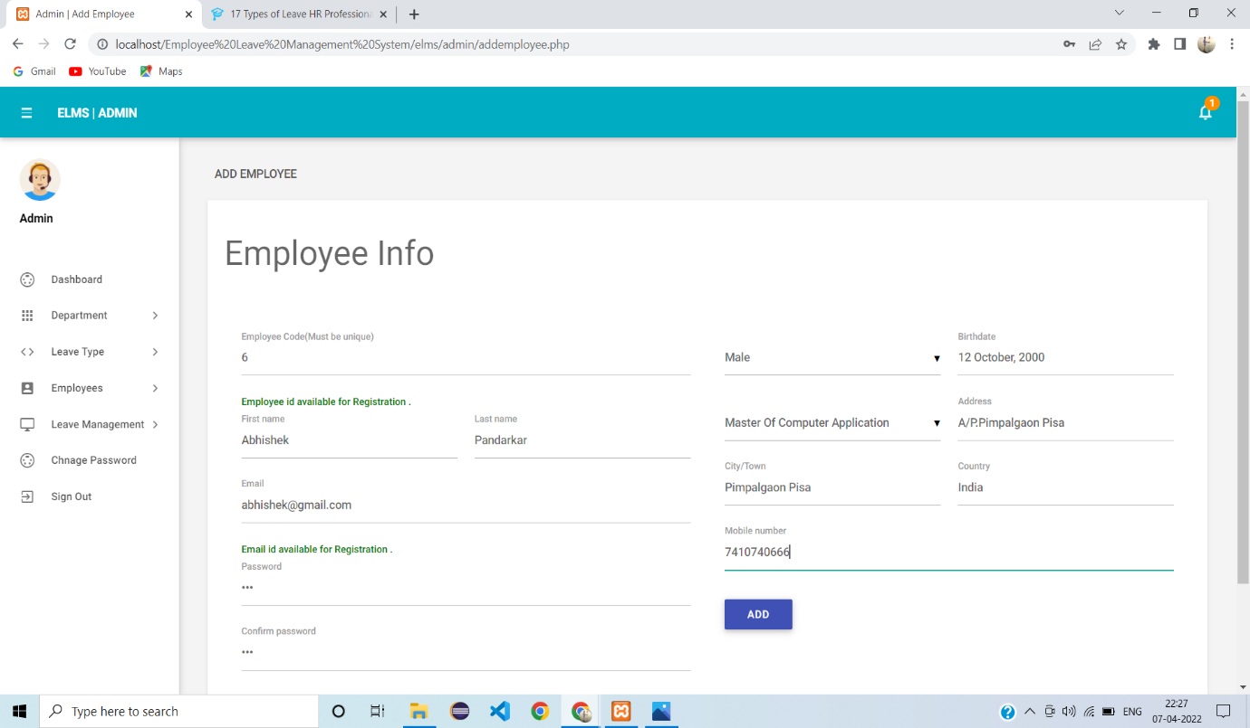

**Manage Employees:**

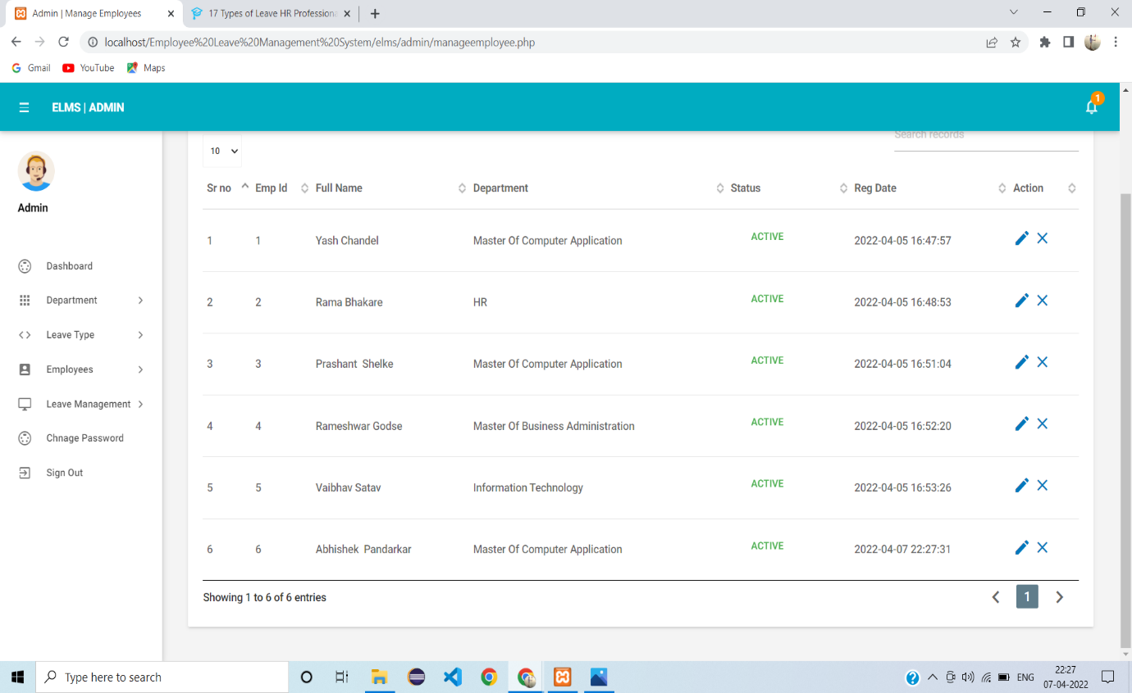

**Add Leave Type:**

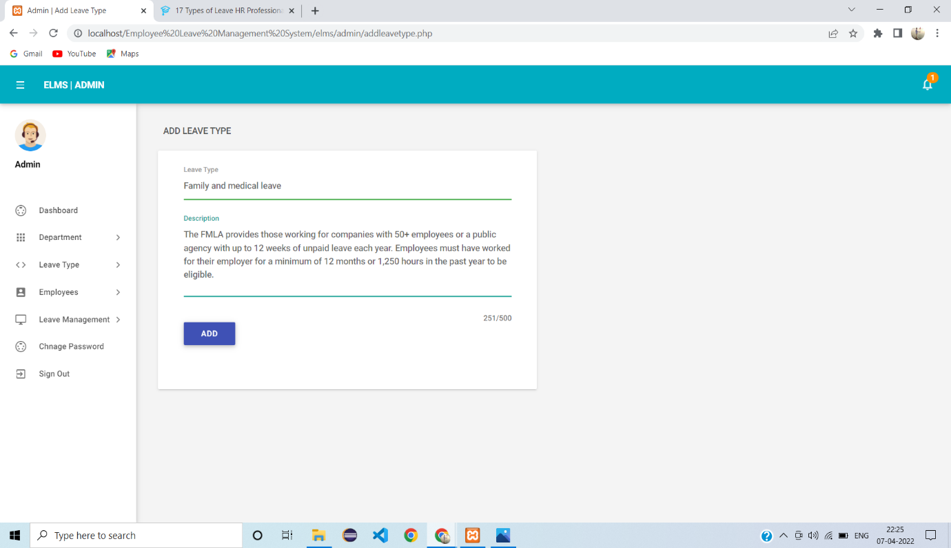

**Manage Leave Type:**

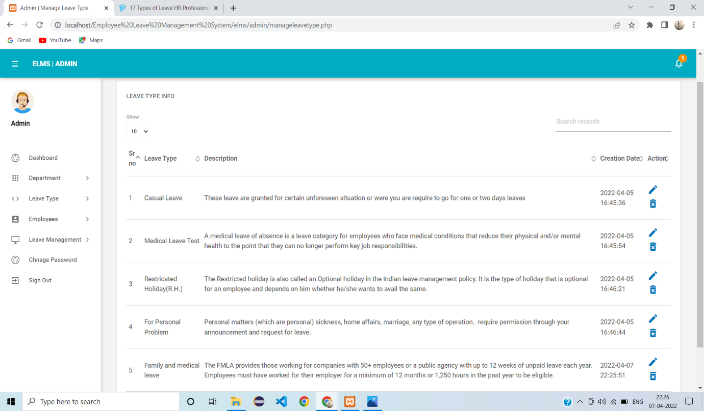

**Add Department:**

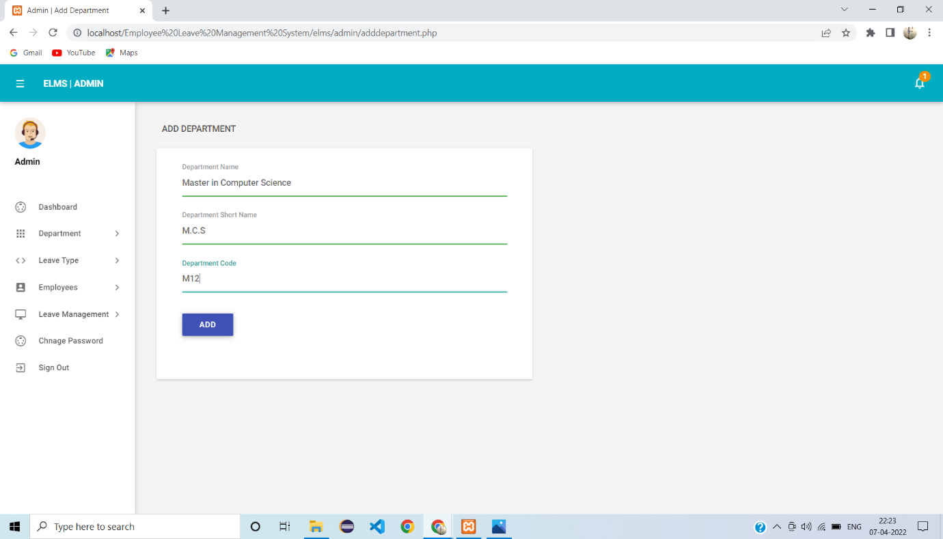

**Manage Department:**

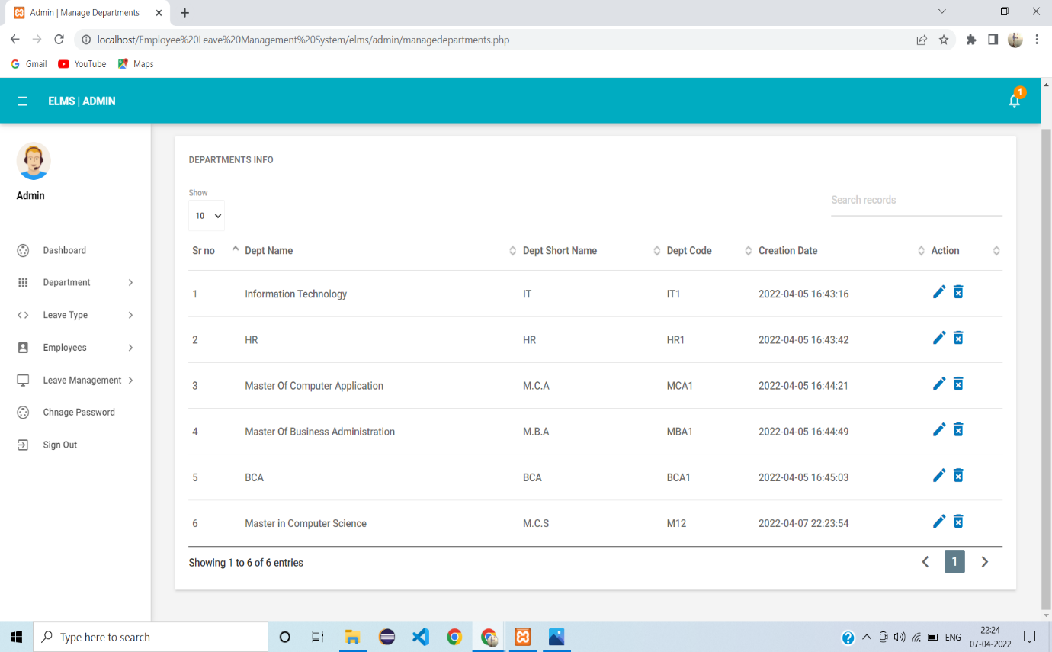

**View Leave Type:**

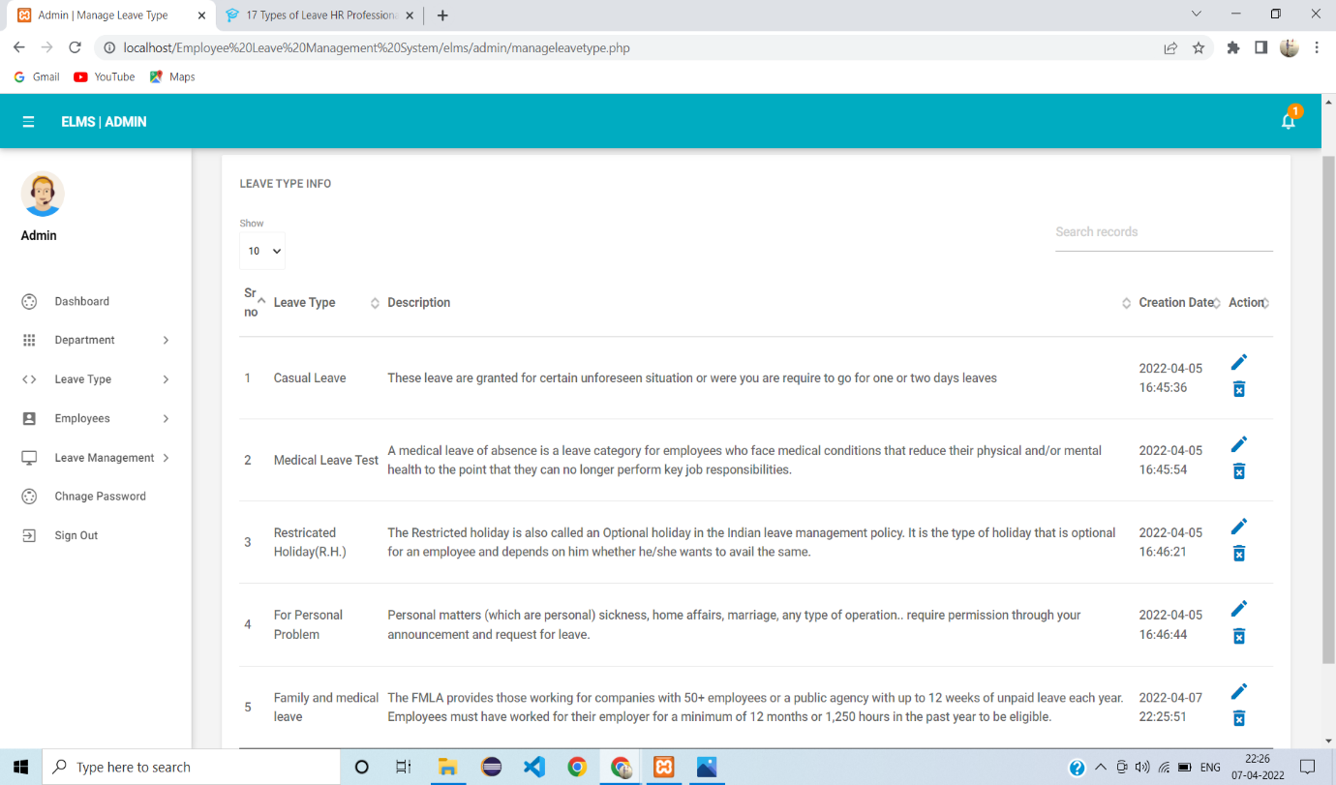

**Employee Login:**

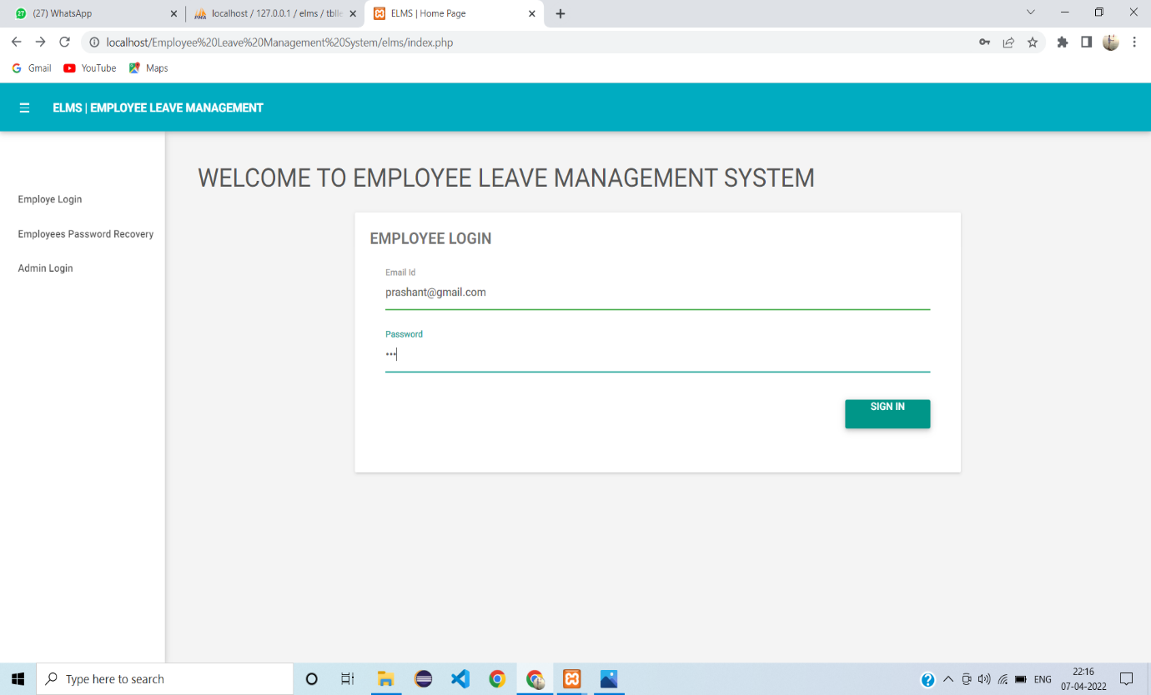

**Employee Password Change:**

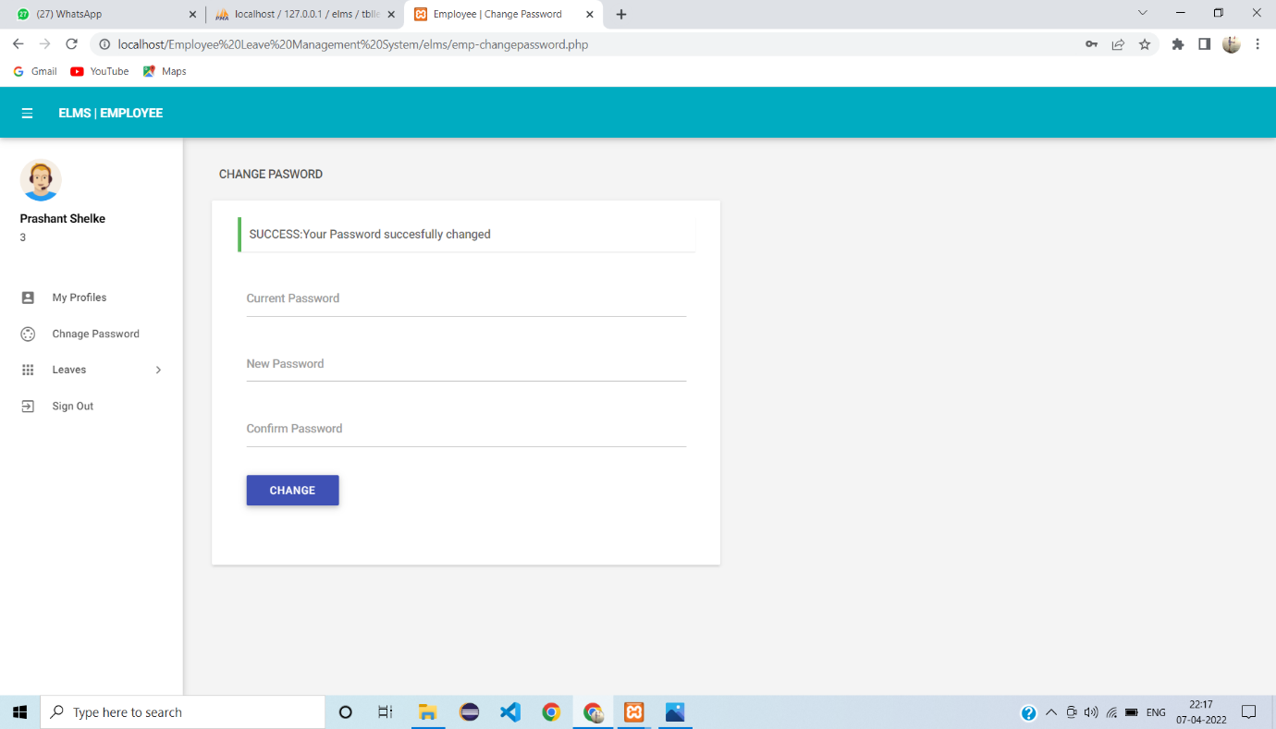

**Update Employee:**

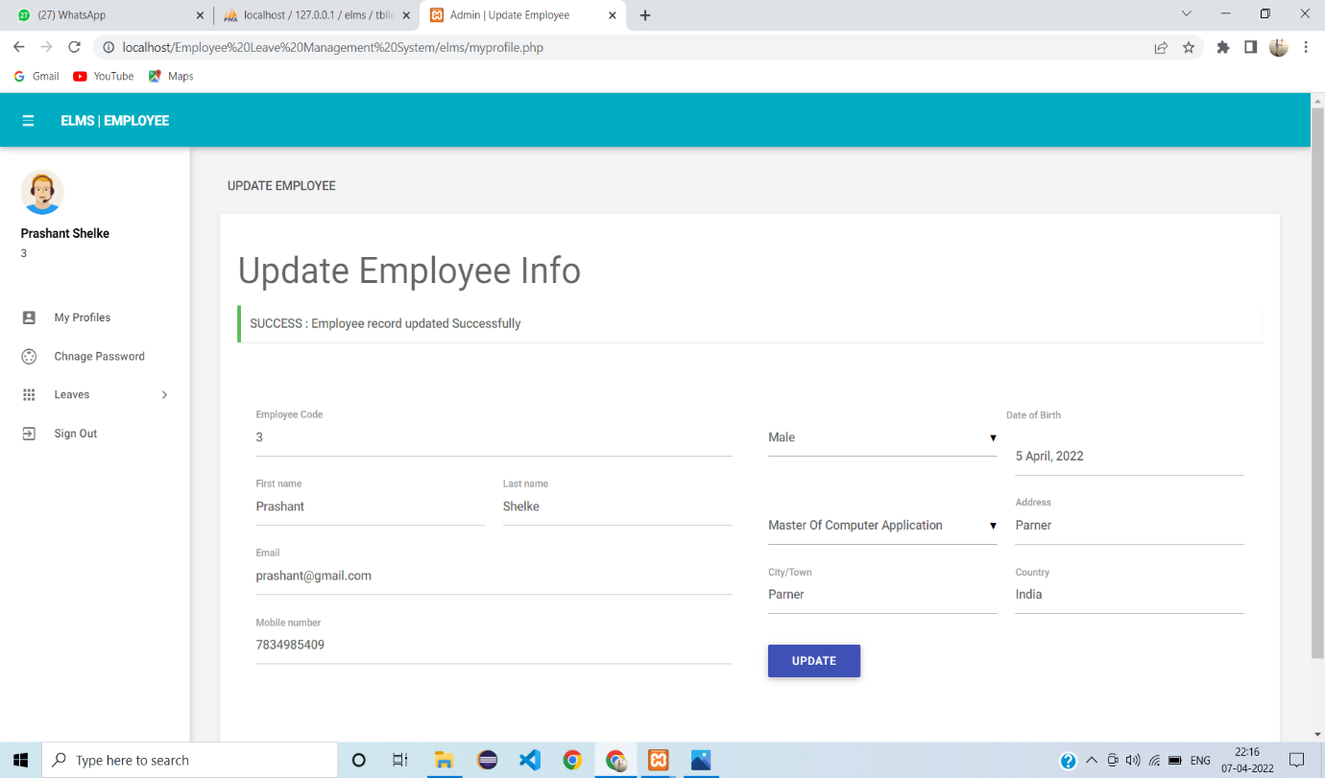

**Apply Leave:**

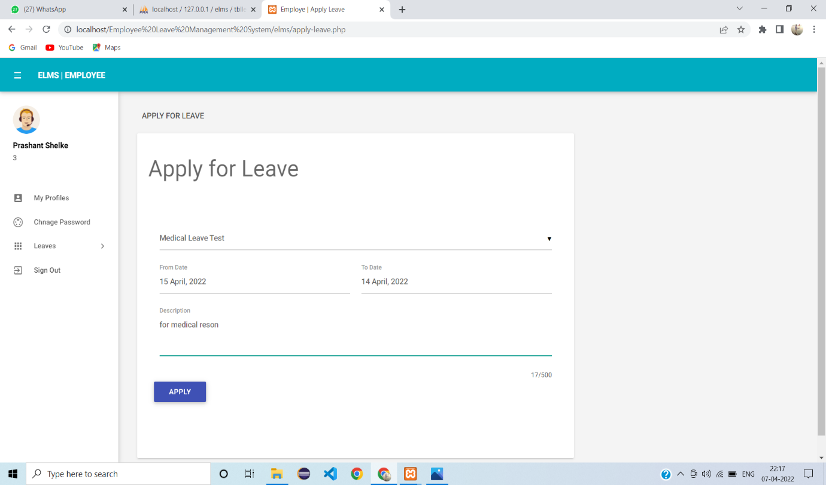

**Take Action:**

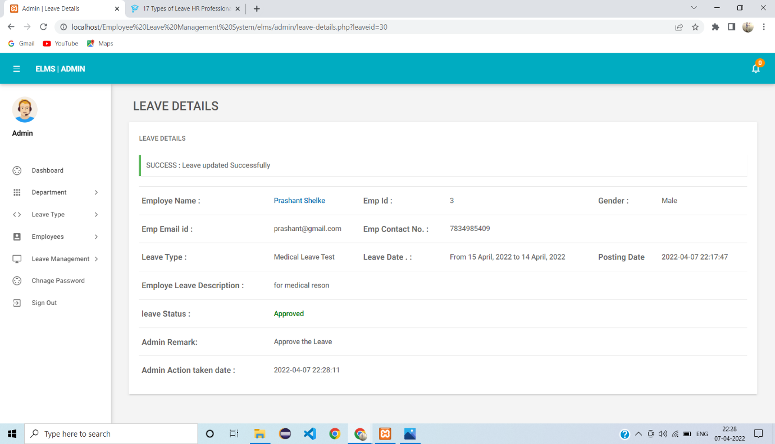

**Employee Leave History:**

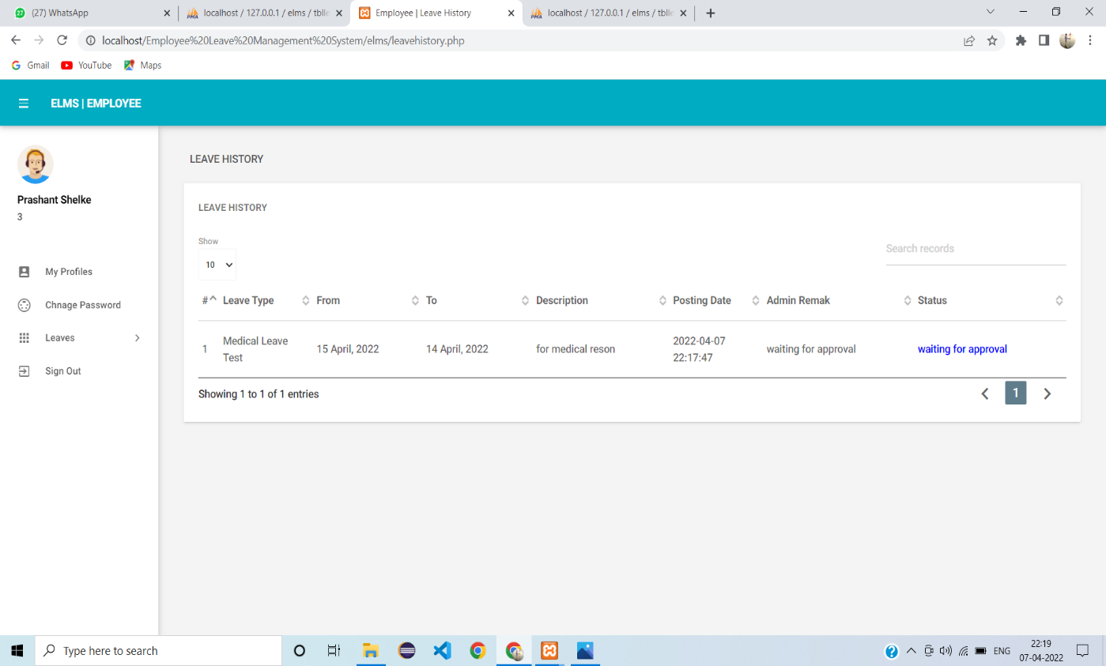

**DATABASE DESIGN**

**Admin Table:**

|  |  |  |  |  |  |
| --- | --- | --- | --- | --- | --- |
| Sr No. | Field Name | Field Size | Data Type | Description | Constraint |
| 1. | Id | 3 | Int | Admin Id | Primary key |
| 2. | User_name | 50 | Varchar | Name of Admin | Not Null |
| 3. | Password | 50 | Varchar | Password of Admin | Not Null |
| 4. | Updation_date | - | Date | Updation Date | Not Null |

**Department Table:**

|  |  |  |  |  |  |
| --- | --- | --- | --- | --- | --- |
| Sr No. | Field Name | Field Size | Data Type | Description | Constraint |
| 1. | Id | 3 | Int | Department Id | Primary key |
| 2. | Department_name | 50 | Varchar | Department Name | Not Null |
| 3. | Department_Short_name | 50 | Varchar | Department Short Name | Not Null |
| 4. | Department_Code | 15 | Varchar | Department Code | Not Null |
| 5. | Creation_Date | - | Date | Creation Date | Not Null |

**Employees Table:**

|  |  |  |  |  |  |
| --- | --- | --- | --- | --- | --- |
| Sr No. | Field Name | Field Size | Data Type | Description | Constraint |
| 1. | Id | 10 | Int | Id | Primary key |
| 2. | Emp_Id | 10 | Int | Employee Id | Not Null |
| 3. | First_Name | 10 | Varchar | Employee First Name | Not Null |
| 4. | Last_Name | 10 | Varchar | Employee Last Name | Not Null |
| 5. | Email_Id | 20 | Varchar | Employee Email Id | Not Null |
| 6. | Password | 10 | Varchar | Employee Password | Not Null |
| 7. | Gender | 10 | Varchar | Employee Gender | Not Null |
| 8. | Dob | - | Date | Employee DOB | Not Null |
| 9. | Department | 10 | Varchar | Employee Department | Not Null |
| 10. | Address | 20 | Varchar | Employee Address | Not Null |
| 11. | City | 20 | Varchar | Employee City | Not Null |
| 12. | Country | 10 | Varchar | Employee Country | Not Null |
| 13. | Phonen_umber | 10 | Number | Employee Phone number | Not Null |
| 14. | Status | 10 | Varchar | Employee Status | Not Null |
| 15. | Reg_Date | - | Date | Registration Date | Not Null |

**Leaves Table:**

|  |  |  |  |  |  |
| --- | --- | --- | --- | --- | --- |
| Sr No. | Field Name | Field Size | Data Type | Description | Constraint |
| 1. | Id | 3 | Int | Employee Id | Primary key |
| 2. | Leave_Type | 20 | Varchar | Leave Type | Not Null |
| 3. | To_Date | - | Date | Leave To Date | Not Null |
| 4. | From_Date | - | Date | Leave From Date | Not Null |
| 5. | Description | 20 | Varchar | Description | Not Null |
| 6. | Posting_Date | - | Date | Posting Date | Not Null |
| 7. | Admin_Remark | 20 | Varchar | Admin Remark | Not Null |
| 8. | Admin_Remark_Date | - | Varchar | Admin Remark Date | Not Null |
| 9. | Status | 10 | Varchar | Status | Not Null |
| 10. | Emp_Id | 10 | Varchar | Employee Id | Primary Key |

**Leaves Type Table:**

|  |  |  |  |  |  |
| --- | --- | --- | --- | --- | --- |
| Sr No. | Field Name | Field Size | Data Type | Description | Constraint |
| 1. | Id | 3 | Int | Employee Id | Primary key |
| 2. | Leave Type | 20 | Varchar | Leave Type | Not Null |
| 3. | Description | 20 | Varchar | Employee Description | Not Null |
| 4. | Creation_Date | - | Date | Creation Date | Not Null |